Homework 2 Student Name: _____________________________

AuE 8200: Machine Perception and Intelligence

Instructor: Dr. Bing Li, Clemson University, Department of Automotive Engineering

* Refer to [Syllabus](https://tinyurl.com/syllabus-perception) for homework grading, submission and plagiarism policies;

* Submission to Canvas (Due: Feb. 9, 2022 11:59 pm), including:

* This document (with answers), and with your program results/visualization;

For this homework, you may put the screenshots of the results in the submission document.

* A .zip file of source code (and data if any) with names indicating question number;

* You can choose either Python, Matlab or any other programming language.

* You can find some sample codes from the course [GitHub Repo](https://github.com/fengziyue/AUE-8939-Perception-Intelligence) if you use Python.

1. For [NuScene](https://www.nuscenes.org/download) dataset access, you may need to register on that website. To save time, you can download only the Full dataset/Mini set: (5 point)

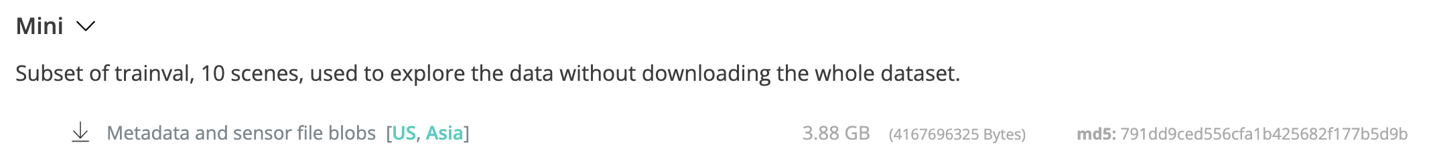

1. If you use Python, set up the NuScene [develop kit](https://github.com/nutonomy/nuscenes-devkit) locally, you may need to install Anaconda and Jupyter notebook; If you use Matlab, setup your Matlab for this data process. (5 point)
2. Pickup a set of data, including Image, Lidar, and Radar data. Visualize them respectively.  
   If you use Python, you can refer to NuScene dev-kit tutorial [reference code](https://github.com/nutonomy/nuscenes-devkit/tree/master/python-sdk/tutorials). (10 points)
3. Rather than using NuScene dev-kit, implement below by yourself (total 35 points):
4. Visualize images (you can use library OpenCV or others), [Sample code](https://github.com/fengziyue/AUE-8939-Perception-Intelligence/blob/main/Homework1/Visualize-Image.py). (5’)
5. Visualize Lidar point cloud data
   1. You can refer to this [sample code](https://github.com/fengziyue/AUE-8939-Perception-Intelligence/blob/main/Homework1/Visualize-Lidar.py).
   2. Colorize points by height, intensity, and semantic label respectively.
      1. Height is the Z value for a point. (5’)
      2. You can get intensity referring the code [here](https://github.com/nutonomy/nuscenes-devkit/blob/5325d1b400950f777cd701bdd5e30a9d57d2eaa8/python-sdk/nuscenes/utils/data_classes.py#L234). (5’)
      3. You can get semantic label from the sample above code. (5’)
6. Visualize Radar data
   1. Use any other library (e.g, Open3D, PCL, etcl) or modify the previous sample code to visualize the Radar data which you chosen. (5’)
   2. Colorize points by below two variable aspects respectively.
      1. For height, (5’)
      2. For velocity, you can find some velocity information from [here](https://github.com/nutonomy/nuscenes-devkit/blob/5325d1b400950f777cd701bdd5e30a9d57d2eaa8/python-sdk/nuscenes/utils/data_classes.py#L259:1). (5’)
7. Using NuScene dev-kit for the set of data which you picked up: (45 points)
8. Visualize Radar data projection on image
   1. Print calibration info (between Radar and Camera sensors) by referring code [here](https://github.com/nutonomy/nuscenes-devkit/blob/5325d1b400950f777cd701bdd5e30a9d57d2eaa8/python-sdk/nuscenes/nuscenes.py#L740). (5’)
   2. Explain the above calibration info, and pipeline of First~Fifth steps in the code. (10’)
   3. Visualize Radar data projection on image based on calibration info. (10’)
9. Visualize LiDAR data projection on image
   1. Print and explain the calibration info (between LiDAR and Camera sensors) by referring [here](https://github.com/nutonomy/nuscenes-devkit/blob/5325d1b400950f777cd701bdd5e30a9d57d2eaa8/python-sdk/nuscenes/nuscenes.py#L740). (5’)
   2. Visualize LiDAR data projection on image based on calibration info. (15’)